**CIRCULAR**

**CLAW/ PRES/2024/008 DATE: 05.09.2024**

The Annual General Body meeting of the alumni association is scheduled to discuss the following agenda below for the academic year 2023- 2024

**Details of the meeting:**

Date: 05/09/2024

Time: 2.00pm- 3.00 pm

Venue: Chettinad Dental College & Research Institute

**Zoom Link:**

Meeting ID: 854 4490 8804

Password: 417537

Meeting Link: <https://us06web.zoom.us/meeting/register/tZEpc2hrjMiGtC0DUNAxB0BaWfSBcc9P5n>

All the members are requested to attend the meeting.

**Co- Ordinator**

**Copy To**

Hon’ble Secretary- For Information

Principal

All Committee Members

Office File

**MINUTES OF MEETING OF CHETTINAD LEGENDARY ALUMNI WING**

**ANNUAL GENERAL BODY MEETING**

**VENUE:** HYBRID Mode: E- block, lecture hall- 14 at Chettinad dental college & research institute & zoom application

**TIME:** 10.00am- 1.00 pm

**DATE:** 06/03/2024

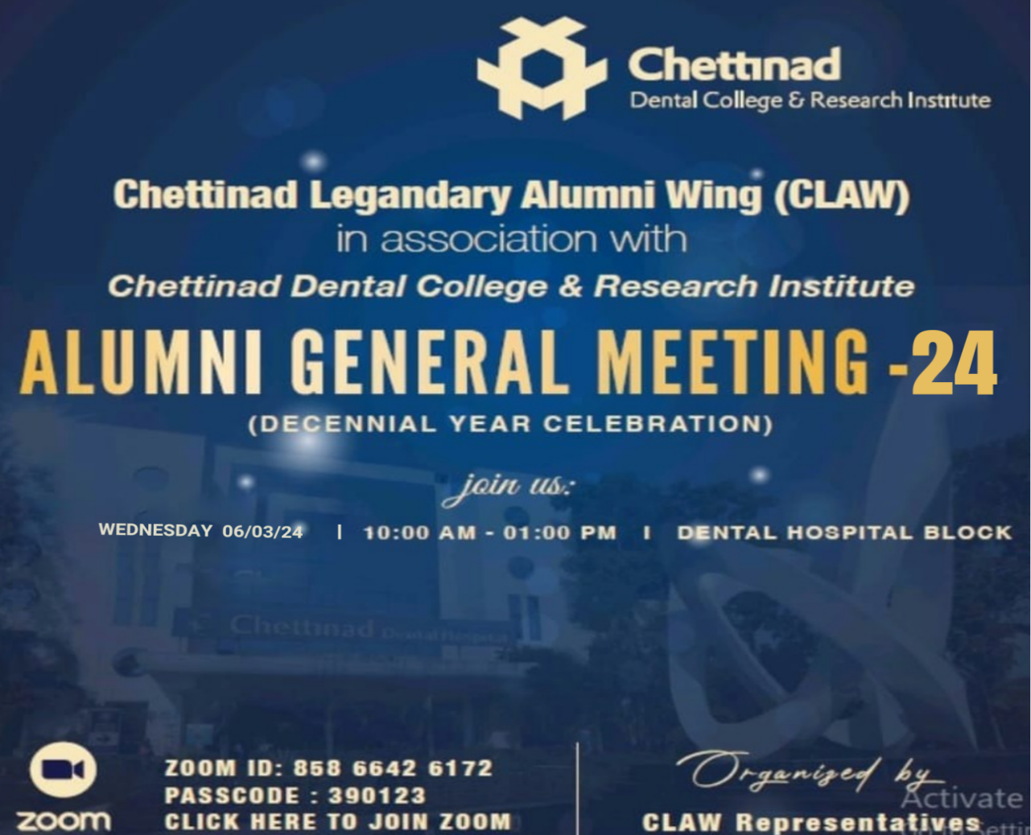

**ZOOM DETAILS:**

Chettinad Academy of Research & Education is inviting you to a scheduled Zoom meeting.

Topic: CLAW Alumni Meet AGM

Time: March 06, 2024 10:00 AM Mumbai, Kolkata, New Delhi

**Zoom Meeting link:**

<https://us02web.zoom.us/j/85866426172?pwd=eEVyZXJBSW5UYmU1Wm5zVWtBYWxjZz09>

**Meeting ID:** 858 6642 6172

**Passcode:** 390123

**MEMBERS ATTENDED:**

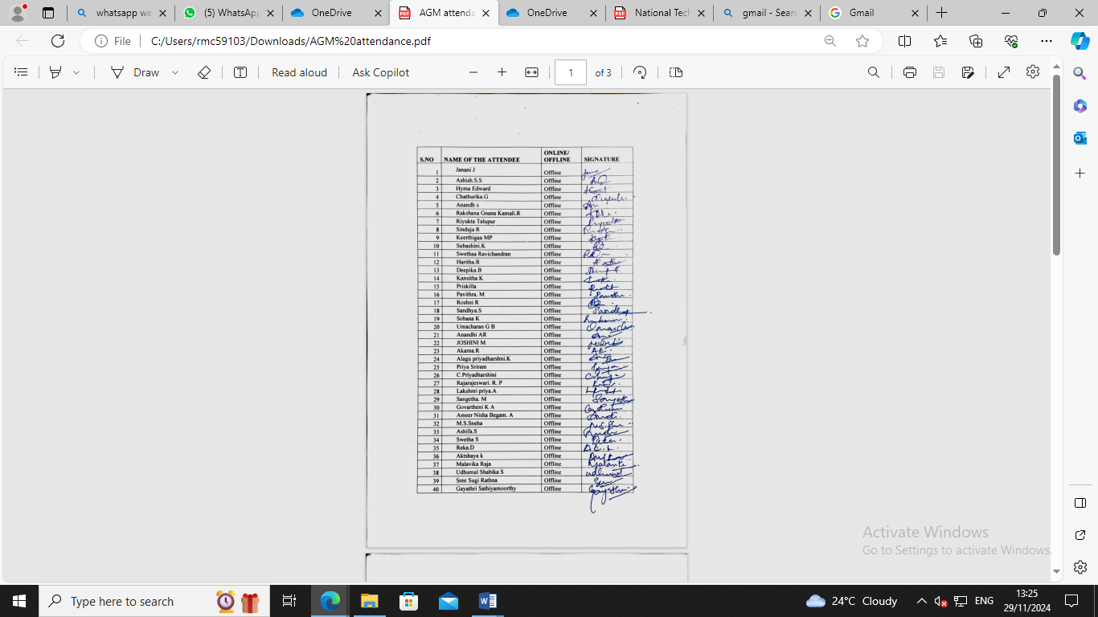

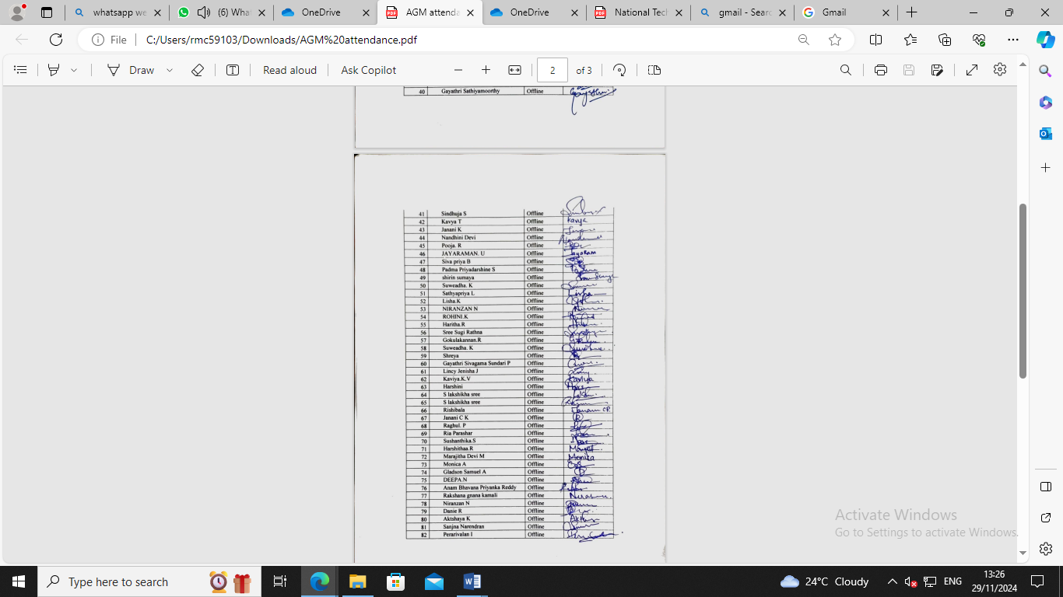

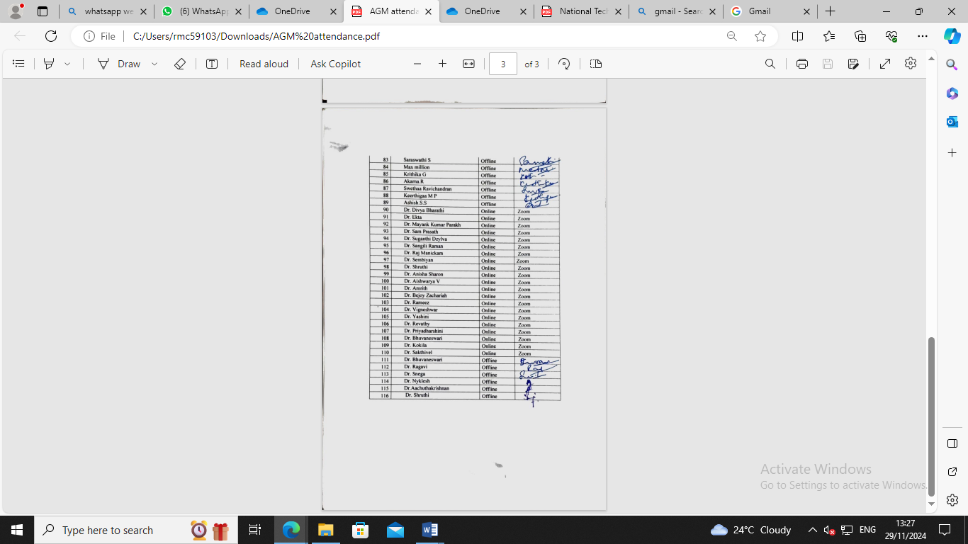

**AGENDA:**

1) To strengthen the bond of CLAW

2) Role of alumni participation in CDCRI (Camp, CDE programs, etc)

3) To improve alumni page in our official college website

4) To get library access for alumni members

5) To motivate current students for good rapport with CLAW

6) To organize/conduct upcoming CDE programs and health camps

7) To setup a new name board for renewal purpose

8) To maintain e-register/form to keep track of all the alumni

9) To discuss about adding or modifying the existing members

10) Future plans for upgrading the CLAW

The meeting was headed by Dr. Ragavi, Secretary, Chettinad Legendary Alumni Wing.

Agenda Item were taken up for discussion.

The resolution passed at this time is as follows:

NOTE: Chettinad Legendary Alumni Wing- AGM- 2024

SUB: Chettinad Legendary Alumni Wing- Annual grand meeting held on 06/03/2024- Draft meeting regarding

The draft minutes of meeting for your kind perusal and approval:

The meeting started by 10.00 am. Dr. Bhuvaneswari, Treasurer listed out the agenda of the meeting. The Secretary, spoke out future plans of the association- for the financial year 2024- 25 as follows:

|  |  |  |
| --- | --- | --- |
| **S.NO** | **TYPE OF EVENT/ PROGRAM** | **DATE** |
| 1 | AGM (2023- 2024) | March |
| 2 | EC Meeting | 11/04/ 2024 |
| 3 | Election Process | May |
| 4 | Election | 15/06/2024 |
| 5 | Alumni Programs | To be co ordinated with Alumni staffs in each dept |
| 6 | Annual Filing | Within 30/04/2024 |
| 7 | EC Meeting | 27/07/2024 |
| 8 | EC Meeting | 21/09/2024 |
| 9 | EC Meeting | 14/12/2024 |

There were few fun activities performed by passed out CRIs. Few students were awarded for their academic excellence.

* Alumni bond need to improve by adding all batch alumni was discussed
* Dr. Ragavi was recommended as Secretary and Dr. Bhuvana was recommended as treasurer by all the EC members
* Alumni contribution for the upcoming year was discussed and also interaction with the current students can be achieved by conducting programs and sessions.
* Alumni Contribution of books and funds was also discussed and proper step will be taken by the society members.
* No of programs/ events/ camp to be conducted by alumni for the student’s support was also discussed.

**GEOTAGGED PHOTOGRAPHS:**

